
CAMBRIDGE LOCAL PLAN 2014: PROPOSED SUBMISSION
Frequently Asked Questions and Guidance on How to Respond

What is the Local Plan?
The Cambridge Local Plan sets out where future development will take place and identifies land for new housing, community facilities, shops and employment. It also identifies land to be protected from development such as the Green Belt and open space. It is the key document that will be used to determine planning applications in the City.

What is the Cambridge Local Plan 2014: Proposed Submission Consultation?
The Cambridge Local Plan 2014: Proposed Submission Consultation runs from 9am on 19 July 2013 to 5pm on 30 September 2013 and comprises the following documents:

- Cambridge Local Plan 2014: Proposed Submission. This is the draft Local Plan for Cambridge.
- Cambridge Local Plan 2014: Policies Map. This is a map which shows sites that have been allocated for residential, employment, university and mixed uses. It also shows designations that are mentioned in the Plan such as open spaces, district, local and neighbourhood centres, areas of major change and opportunity areas.
- Cambridge Local Plan 2014: Sustainability Appraisal. This report assesses the effects that the draft plan (Cambridge Local Plan 2014: Proposed Submission) has on issues relating to sustainability. It is a legal requirement.

Why are we consulting?
As part of preparing the new Local Plan, the National Planning Policy Framework requires local planning authorities to:
- Indicate broad locations for strategic development on a key diagram and land-use designations on a policies map;
- Allocate sites to promote development and flexible use of land, bringing forward new land where necessary, and provide detail on form, scale, access and quantum of development where appropriate;
- Identify areas where it may be necessary to limit freedom to change the use of buildings, and support such restrictions with a clear explanation; and
- Identify land where development would be inappropriate, for instance because of its environmental or historic significance.

How can I have my say on the Cambridge Local Plan consultation?
You can respond to our consultation in a number of ways. We have provided further information for you below. The consultation runs from:

9am on 19 July 2013 to 5pm on 30 September 2013.

Using our online consultation system

The online consultation system is our preferred means of receiving comments as it ensures that your comments are summarised and recorded accurately and are processed quickly. We would especially encourage all statutory consultees, agents and landowners to use the online consultation system. Click here (or go to page 6 of this document) to read instructions on how to use the online consultation system.

You can access the online consultation system by going to this address:
http://cambridge.jdi-consult.net/ldf/

Responding in writing

If you cannot reply to the consultation using the online consultation system, it would be helpful if you could fill in our response form. This makes sure that we have all the correct information to register and process your views and to keep you informed of progress on the Local Plan Review.
Forms may be:
- Filled in electronically and emailed to us at policysurveys@cambridge.gov.uk
- Downloaded from our website (https://www.cambridge.gov.uk/draft-local-plan-2014), filled in by hand and posted to us at Draft Local Plan Consultation, Planning Policy, Cambridge City Council, PO Box 700, Cambridge, CB1 0JH.
- Or obtained by contacting the Council on 01223 457000 and asking to speak to someone in the Planning Policy team or by visiting the Customer Service Centre at Mandela House, 4 Regent Street, Cambridge CB2 1BY (open from the following times: Monday - 8am to 5.15pm, Tuesday - 9am to 5.15pm, Wednesday - 9am to 6pm, Thursday - 9am to 5.15pm, Friday - 9am to 5.15pm)

Please fill in a separate form for each comment that you make.

For more detailed information on how to complete the form, click here or go to page 9 of this document.

Data Protection

The information collected will be processed in accordance with the Data Protection Act 1998. Information from the forms will be stored on a computer database used solely in connection with the Local Plan Review. Representations will be available to view on the Council’s website, although address and contact details will not be included. However, as copies of representations must be made available for public inspection, they cannot be treated as confidential and will be available for inspection in full.

WHEN CAN I COMMENT?

Representations on the consultation documents must be submitted during the ten-week period between:

9am on 19 July 2013 to 5pm on 30 September 2013.

Comments received after this deadline will not be accepted.

Sending emails or replying by using the online consultation system may be difficult on the last day of the consultation as electronic services may get very busy. Please try to reply before the last day to guarantee that your reply gets to us in good time.

Legal Requirements and Test of Soundness

To meet the legal requirements both the paper representation form and the online consultation system will ask you a series of questions. These questions are a requirement of the National Planning Policy Framework. We are asking you to assess the policy or paragraph that you are responding to by asking you whether you think that the policy or paragraph is:

- Legal – complies with the law
- Positively prepared - the plan should be prepared based on a strategy which seeks to meet objectively assessed development and infrastructure requirements, including unmet requirements from neighbouring authorities, where it is reasonable to do so, and consistent with achieving sustainable development;
- Justified - the plan should be the most appropriate strategy, when considered against the reasonable alternatives, based on proportionate evidence;
- Effective - the plan should be deliverable over its period and based on effective joint working on cross-boundary strategic priorities;
- Consistent with National Policy - the plan should enable the delivery of sustainable development in accordance with the policies in the National Planning Policy Framework.

On the paper representation form, these questions are covered by questions 4 to 6. On the online system, these questions will appear if you object to a policy or paragraph.

Verbally expressing your views to an Independent Inspector

When objecting to the consultation, you will be asked if you wish to verbally express your views to an independent inspector at the examination into the plan.

On the paper representation form, this is question 7.
On the online consultation system, this question will appear at the bottom of your response form if you object to a policy or paragraph.

After the consultation has ended the Local Plan will be submitted to an independent examiner, who will assess the plan to say whether they believe that it is suitable to be adopted. Part of this process involves an examination in public, which consists of a number of hearing sessions which discuss matters relating to the legality and soundness of the plan. If you wish to verbally express your views to the independent inspector, this is the forum in which you would speak. Further information on this process can be found by visiting: http://www.pas.gov.uk/pas/aio/25131

What will happen to my representation?

After the end of the consultation period you will be sent an acknowledgement stating your personal identification number and the reference numbers corresponding to your representation(s). These reference numbers must be given on any future correspondence and/or when telephoning the Council. Only valid representations will be acknowledged.

What happens next?

Once the consultation period has finished, we will analyse and consider all the responses that we receive. We then intend to submit the Local Plan to the Secretary of State for examination, together with all the responses. To find out when this will happen, visit the Local Plan review page or visit our blog: cambridgelocalplan.wordpress.com.

Contacting us

We are here to help. If you have any queries, please contact us at:

Draft Local Plan Consultation

Planning Policy

Cambridge City Council
PO Box 700

Cambridge
CB1 0JH

Tel: 01223 457000

Website: https://www.cambridge.gov.uk/draft-local-plan-2014
Email: policysurveys@cambridge.gov.uk

The deadline for receipt of completed forms is 5pm on 30 September 2013.

Are there any other relevant consultations taking place?
There are two other consultations that are also taking place at the same time as our consultation

- Cambridgeshire County Council is consulting on their Transport Strategy for Cambridge and South Cambridgeshire. The Strategy has taken into account the Cambridge Local Plan 2014: Proposed Submission in order to look at providing additional capacity and dealing with the transport demands of new residents and workers as a result of the draft Cambridge Local Plan. To find out more visit: www.cambridgeshire.gov.uk/tscsc
- South Cambridgeshire District Council is consulting on their draft Local Plan. Cambridge City Council and South Cambridgeshire District Council have worked closely together to assess sites on the Cambridge/South Cambridgeshire border. To find out more about the South Cambridgeshire Local Plan visit: http://www.scambs.gov.uk/content/south-cambridgeshire-local-plan
How to Use the Online Consultation System

- You can access the online consultation system by going to this address:
http://cambridge.jdi-consult.net/ldf/

- If you wish to respond to the consultation and you have never used the system before, you will need to register first. To do this, click the “register now” link at the top of the webpage:

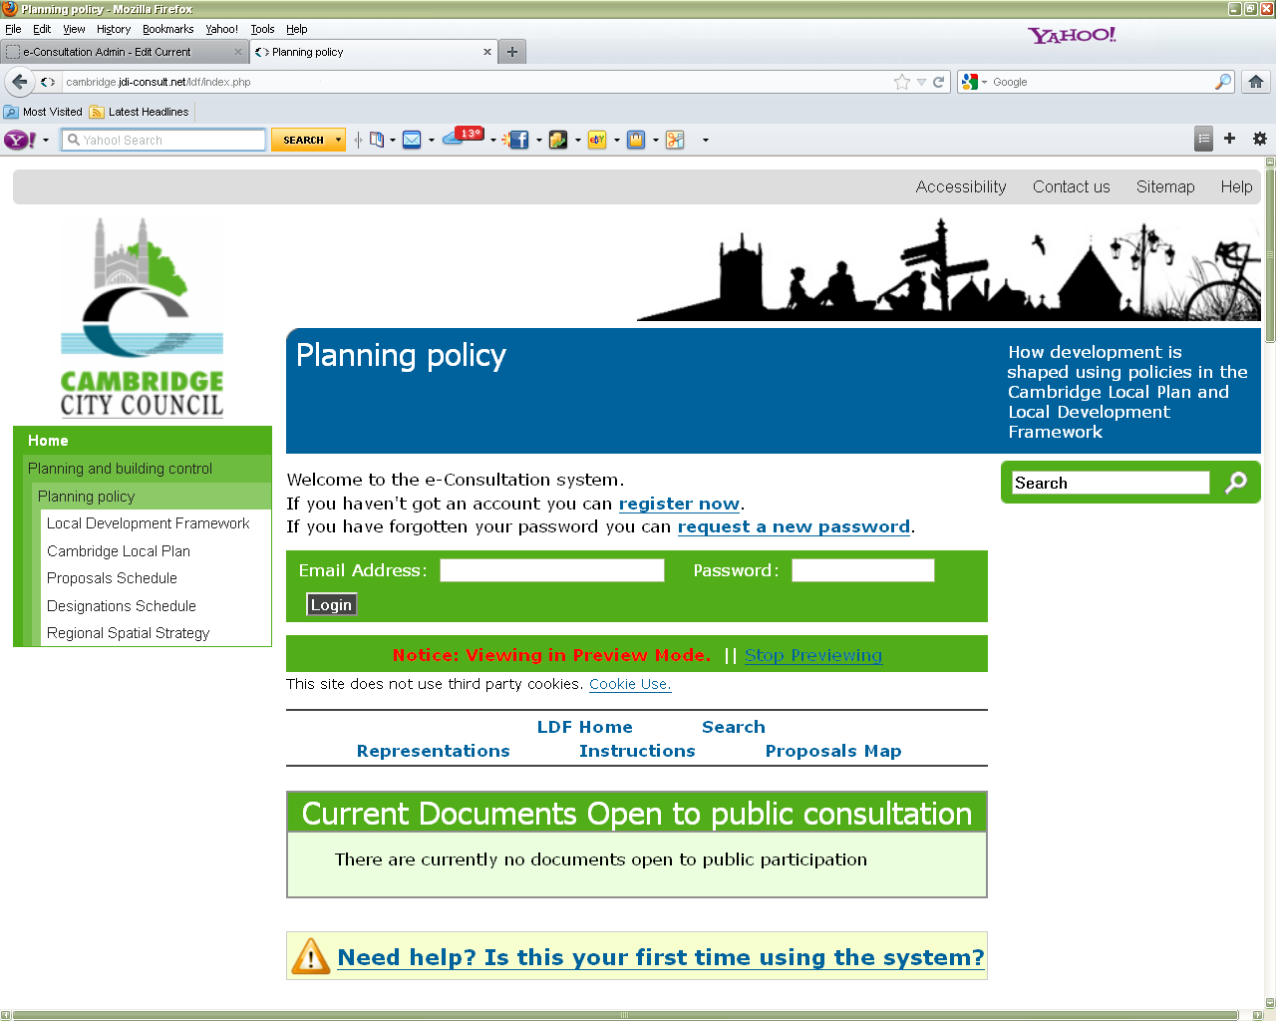

- You will then need to fill in some details about yourself. This will allow the Council to keep you informed about the progress of the Local Plan Review. You will also need to create a password, which will allow you to return to the site and comment on other consultations in the future.

- After you have registered, you will be taken back to the main consultation page and your name will appear in the top left of the screen. This means that you are logged into the system and are able to make representations.

- To make comments on your chosen consultation document, scroll down the page to the section called “Current documents open to public participation” and select the document that you wish to respond to.

- You can then browse through the document on screen and when you wish to make a comment about a particular piece of text, click the pencil icon next to the text: 

- Then you put your comments in the box marked “Full Text of Representation.” If the text of your representation is over 100 words, you will need to summarise it in the box below entitled “Representation Summary.”

- If you object to a policy or paragraph the online consultation system will ask you additional questions. See page 3 - Legal Requirements and Test of Soundness and page 4 - Verbally expressing your views to an Independent Inspector for further details on this.

- When you have finished, remember to click the submit button at the bottom of the page. You can then continue making more comments, repeating steps 6 and 7.

- You will receive an email confirming that we have received your comments.

- If you leave the site and come back to it and wish to make further representations, you will not need to register again, but you will need to log in. To log into the system, go to http://cambridge.jdi-consult.net/ldf/. You will need to put your email address and password into the boxes at the top of the page.

- If you have forgotten your password, you can request a temporary replacement that will be emailed to you by clicking the “request temporary replacement” link above the boxes where you log in.

- If you would like further information on this consultation, visit https://www.cambridge.gov.uk/draft-local-plan-2014

USING THE PAPER REPRESENTATION FORM

Please ensure you provide all the contact details requested on the form. This information will be used for correspondence. If we are advised that an agent is acting on behalf of a client, the agent will be the point of contact for all future correspondence.

You must make clear which document you are responding to and whether you are supporting or objecting to the part of the document you have identified

Questions 4 to 6 deal with the issue of Legality and Soundness. See page 3 - Legal Requirements and Test of Soundness for more details on the subject.

Question 7 asks whether you wish to verbally express your views to an independent inspector see page 4 - Verbally expressing your views to an Independent Inspector for further details on this.

Written Justification for Objection or Support – Question 8

If you support a policy: give any reasons that you would like to give for that support.
If you object to a policy: please provide information to support your reasons for objecting, as precisely as possible. Please continue on separate A4 sheet(s) if necessary.

Summary Checklist for Completing the Response Form

The following is a checklist for all those completing the Response Form.

CHECKLIST

Once your representations are complete, please check that you have completed each form clearly and legibly using black ink, or by typing your response, and:

- Provided full and up to date contact details;
- Included information about the section of the report to which you are submitting your representation (for example paragraph number);
- Made it clear whether you are supporting or objecting to the section of the report (Question 4);
- Included a ‘Written Justification’ for your representation (Question 8);
- Please ensure you have signed and dated the form and returned all completed forms together to the address on this Guidance Note before 5pm on 30 September 2013.

